# **Prediction Intervals Exercise**

## To find how many samples it takes to find the lower and upper bounds of a sample set on average? This exercise simulates finding the upper and lower boundary of a sequential range by sampling the result of dice rolls.

## The process

**3 x 6 Sided Dice**

1. 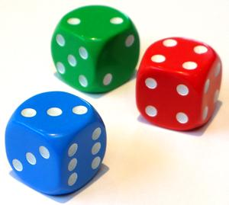**Roll Dice**: Create a random number with a range of 1 to 100. Options:
   1. A random number generator app on your phone (Randomizers)
   2. Use three rolls of a six-sided dice (see next page for chart)
   3. Sum two 10 sided dice (00 – 90 by 10’s) and a traditional (0-9)
2. **Repeat**: Repeat 20 times and record the results in the table below.

**2 x 10 Sided Dice**

1. 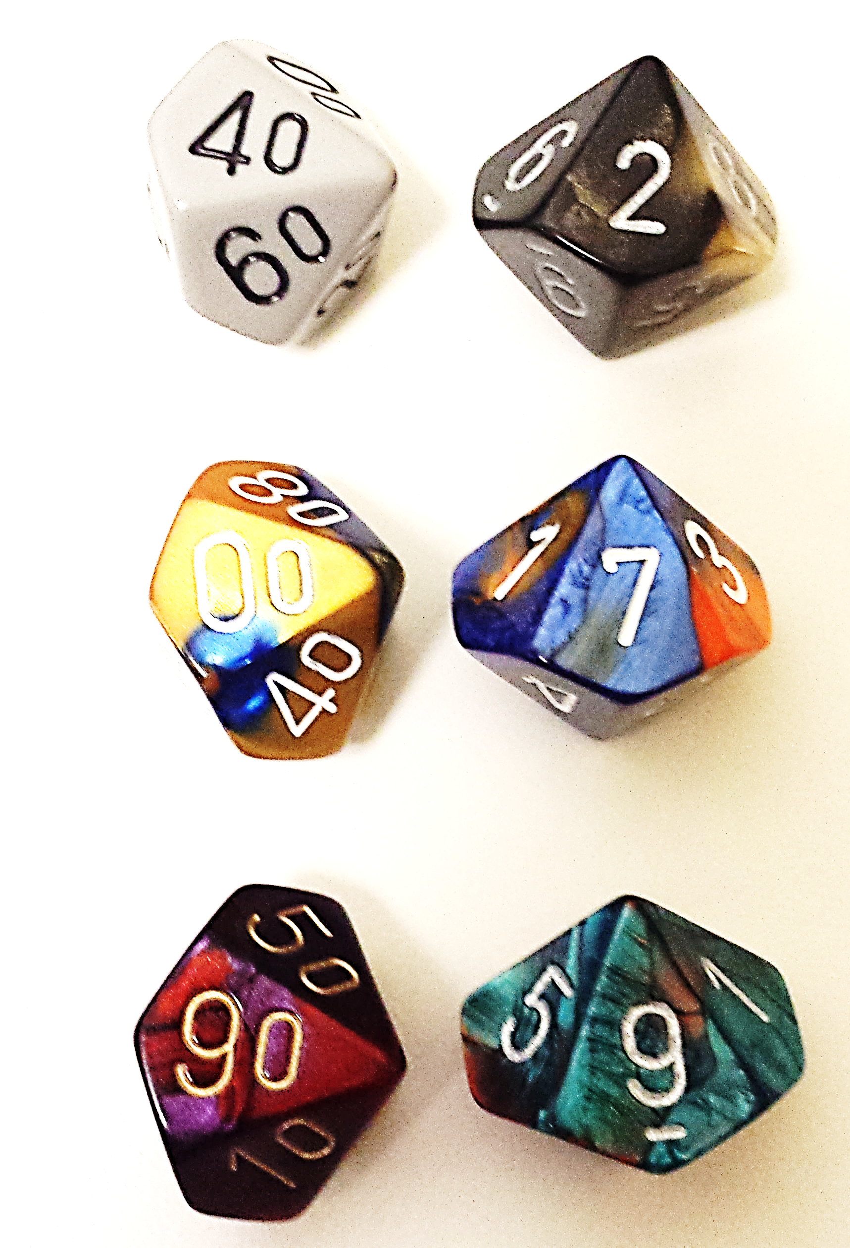**Examine Results**: Look at the range between the lowest rolled and highest rolled. Compare against expected.

42

## Questions and discussion topics

7

1. **What probability distribution is a single roll?**
2. **What guarantee do I have that I have found the range expected?**
3. **What happens if the data is a Normal (bell curve) distribution?**

99

1. **What happens if the data is left or right skewed?**

**Note: Rolling a 00 and 0 = 100**

## Results table

Record each roll and calculate the ranges seen so far after each roll. Are you ahead or behind expected?

|  |  |  |  |  |  |  |
| --- | --- | --- | --- | --- | --- | --- |
| **n** | **This Roll** | **Lowest  So Far** | **Highest  So Far** | **Range So Far =  Highest-Lowest** | **Expected Range $$\frac{(n-1)}{(n+1)} × 100$$** | **Average So Far  (expected 50)** |
| **1** |  |  |  |  | **0** |  |
| **2** |  |  |  |  | **33.3** |  |
| **3** |  |  |  |  | **50** |  |
| **4** |  |  |  |  | **60** |  |
| **5** |  |  |  |  | **66.6** |  |
| **6** |  |  |  |  | **71.4** |  |
| **7** |  |  |  |  | **75** |  |
| **8** |  |  |  |  | **77.8** |  |
| **9** |  |  |  |  | **80** |  |
| **10** |  |  |  |  | **81.2** |  |
| **11** |  |  |  |  | **83.3** |  |
| **12** |  |  |  |  | **84.6** |  |
| **13** |  |  |  |  | **85.7** |  |
| **14** |  |  |  |  | **86.7** |  |
| **15** |  |  |  |  | **87.5** |  |
| **16** |  |  |  |  | **88.2** |  |
| **17** |  |  |  |  | **88.9** |  |
| **18** |  |  |  |  | **89.5** |  |
| **19** |  |  |  |  | **90** |  |
| **20** |  |  |  |  | **90.5** |  |

# **One to One Hundred (1-100) Random Numbers Using Six Sided Dice**

**First Roll**

 OR 

**Third Roll**

**Second Roll**

|  |  |  |  |  |  |  |
| --- | --- | --- | --- | --- | --- | --- |
|  |  |  |  |  |  |  |
|  | **1** | **2** | **3** | **4** | **5** | **6** |
|  | **7** | **8** | **9** | **10** | **11** | **12** |
|  | **roll again** | **13** | **14** | **15** | **16** | **17** |
|  | **18** | **19** | **20** | **21** | **22** | **23** |
|  | **24** | **roll again** | **25** | **26** | **27** | **28** |
|  | **29** | **30** | **31** | **32** | **33** | **34** |

 OR 

**Example:**

1. Roll three six-sided dice, or one six-sided dice 3 times.
2. Consider:  
   Roll 1 = **3** (table)  
   Roll 2 = **5** (vertical)  
   Roll 3 = **4** (horiz.)
3. The value is at the intersection of 5 and 4 in the middle table = **60**

|  |  |  |  |  |  |  |
| --- | --- | --- | --- | --- | --- | --- |
|  |  |  |  |  |  |  |
|  | **35** | **36** | **roll again** | **37** | **38** | **39** |
|  | **40** | **41** | **42** | **43** | **44** | **45** |
|  | **46** | **47** | **48** | **roll again** | **49** | **50** |
|  | **51** | **52** | **53** | **54** | **55** | **56** |
|  | **57** | **58** | **59** | **60** | **roll again** | **61** |
|  | **62** | **63** | **64** | **65** | **66** | **67** |

 OR 

|  |  |  |  |  |  |  |
| --- | --- | --- | --- | --- | --- | --- |
|  |  |  |  |  |  |  |
|  | **68** | **69** | **70** | **71** | **72** | **roll again** |
|  | **73** | **74** | **75** | **76** | **77** | **78** |
|  | **79** | **80** | **81** | **82** | **83** | **84** |
|  | **roll again** | **85** | **86** | **87** | **88** | **89** |
|  | **90** | **91** | **92** | **93** | **94** | **95** |
|  | **96** | **roll again** | **97** | **98** | **99** | **100** |